horizontal line



**Project 2 Report**

10.14.2023

**─**

Summehra Hassan

Khwahish Daudani

**Problem Description:**

The purpose of this project is to create a program for a water utility company that will calculate the amount of money that a specified customer will be billed for water usage. For specific customers, the code will be calculated in three different categories such as residential, commercial, and industrial. The code will first calculate the gallons of water used by the customer, then it will calculate the amount of money the customer will be billed.

**Major Implementation:**

Throughout the program, what was most interesting was implementing the customer code into three different categories, though it was also the most difficult to implement. Due to the program prompting the user to specify the customer code into three categories, calculation and syntax errors were common when writing the program. Though the code doesn’t have any errors as of right now, the error that had to be fixed the most throughout the program was the “to_bill” character. When running tests for the program, the “to_bill” character would either be an undefined character or it would be assigned with an incorrect variable. Finally, if the program were to receive a bad input or edge case, such as a variable being other than the assigned variables of R, C, I, or an integer being out of the range of 0 and 999999999, then the program would label those inputs as an “invalid input.”

**Lessons Learned:**

What went well in this project was being able to solve the problem given. Throughout writing the program, we were able to understand how to write the customer code, what variables that needed to be implemented, what had to be calculated, and what bugs and errors that needed to be fixed. However, what we could’ve done differently if we were given the opportunity to have more time writing the code would be experimenting with different code statements to see whether or not it saves more time as it tries to give the output. Though the project went well, what we could’ve done to make the project more clearer/satisfying would be being able to use the exit function to help save time when it came to coding errors. Another thing that we could've done to make the project more clear would be being able to use numbers instead of variables because when writing the program, some of the variables had the same exact numbers. Also, due to the code being very long and complex, what the instructors and TAs could’ve done differently would be explaining the project, specifically the coding part, a little more clearly.

**Handwritten Solution:-**

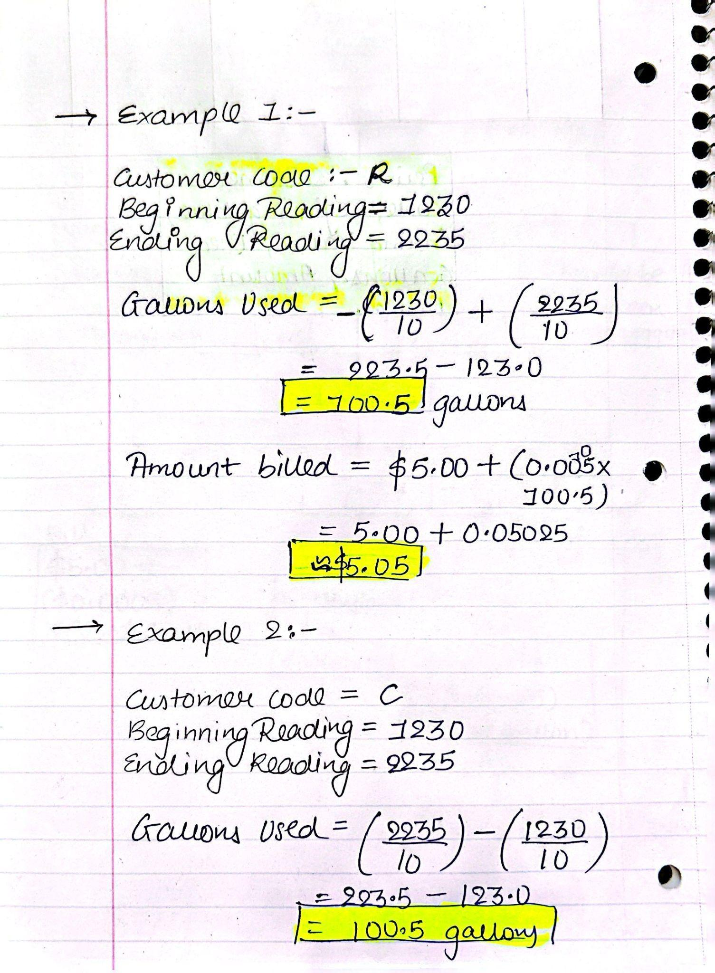

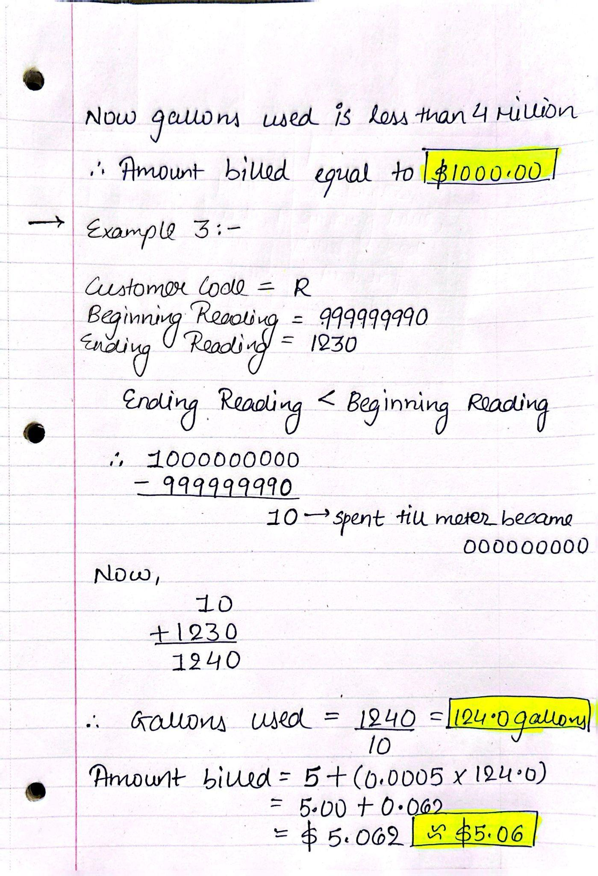

**Pseudo code:**

Minimum Reading = 0

Maximum Reading = 999999999

Residential Basic Bill amount = 5.00

Residential amount bill per gallon = 0.0005

Commercial Basic Bill Amount = 1000.00

Commercial cut off = 4000000

Commercial amount bill per gallon = 0.00025

Industrial Basic bill amount = 1000.00

Industrial Lower Cut off = 4000000

Industrial Basic bill amount 2 = 2000.00

Industrial higher cut off = 10000000

Industrial Amount billed per gallon = 0.00025

Customer code = input('Enter customer code (R, C, or I):')

if Customer code is not R, C or I:

Output('Invalid input (customer code)')

else:

Beginning Reading = (input only or integers('Enter beginning reading (between 0 and 999999999):'))

Ending Reading = (input only or integers('Enter ending reading (between 0 and 999999999):'))

if 0 is less than or equal to Beginning Reading is less than or equal to 999999999 or 0 is less than or equal to Ending Reading is less than or equal to 999999999 is not implied :

output('Invalid input (beginning or ending reading value is out o the range)')

else:

if Ending Reading is less than Beginning Reading then:

Gallons Used = (999999999 + 1 - Beginning Reading + Ending Reading) / 10

Or else:

Gallons Used = (Ending Reading / 10) - (Beginning Reading / 10)

if Customer code is 'R':

Amount Billed = $5.00 + $0.0005 * Gallons Used

And if Customer code is 'C then':

if Gallons Used is less than or equal to 4 Million:

Amount Billed = $1000.00

else:

Amount Billed = $1000.00 + $0.00025 * (Gallons Used - 4,000,000)

When Customer code is ‘I’:

if Gallons Used is less than or equal to 4 Million:

Amount Billed = $1000.00

And if Gallons Used is less than or equal to 10 Million:

Amount Billed = $2000.00

else:

Amount Billed = $2000.00 + $0.00025 * (Gallons Used - 10,000,000)

Output ('Customer code: {Customer code}')

Output('Beginning reading value in gallons and tenths of gallon {Beginning Reading / 10 (Rounded to 1 decimal place)}')

Output('Ending reading value in gallons and tenths of gallon {Ending Reading / 10.0(Rounded to 1 decimal place)}')

Output('Gallons of water used: {Gallons Used(Rounded to 1 decimal place)}')

Output('Amount billed: ${Amount Billed (Rounded to 2 decimal place)}')

**IPO:- (Input and output are highlighted in Yellow)**

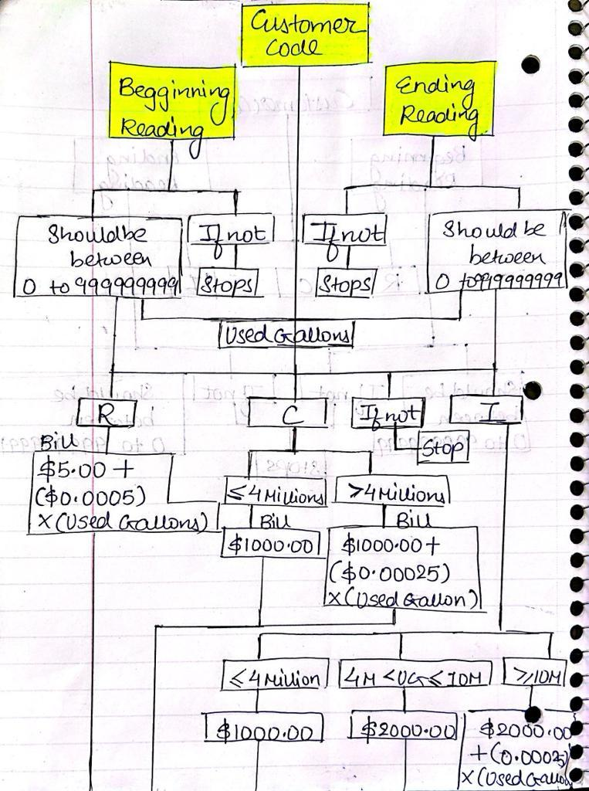

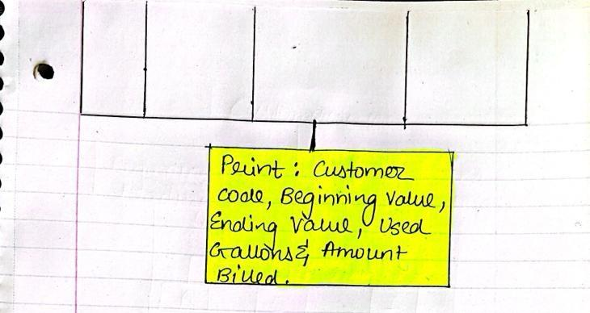

**Flowchart:**

